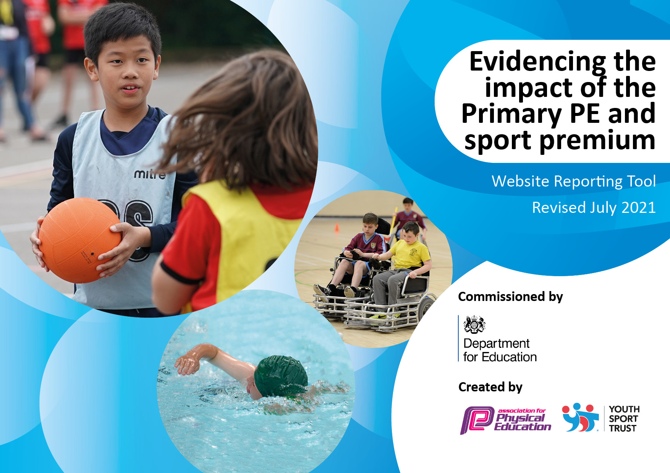
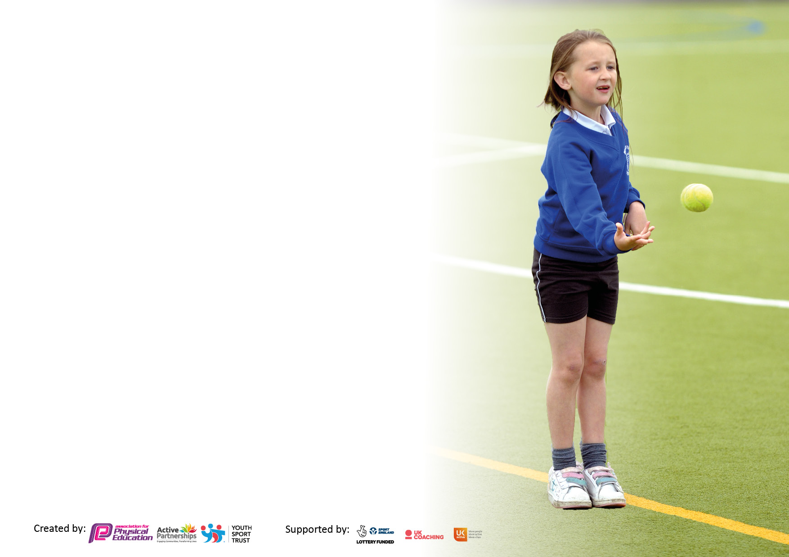

It is important that your grant is used effectively and based on school need. The Education Inspection Framework makes clear there will be a focus on ‘whether leaders and those responsible for governors all understand their respective roles and perform these in a way that enhances the effectiveness of the school’.

Under the Quality of Education Ofsted inspectors consider:
Intent - Curriculum design, coverage and appropriateness
Implementation - Curriculum delivery, Teaching (pedagogy) and Assessment
Impact - Attainment and progress

To assist schools with common transferable language this template has been developed to utilise the same three headings which should make your plans easily transferable between working documents.

Schools must use the funding to make additional and sustainable improvements to the quality of Physical Education, School Sport and Physical Activity (PESSPA) they offer. This means that you should use the Primary PE and sport premium to:

- Develop or add to the PESSPA activities that your school already offer
- Build capacity and capability within the school to ensure that improvements made now will benefit pupils joining the school in future years
- The Primary PE and sport premium should not be used to fund capital spend projects; the school’s budget should fund these.

Pleasevisitgov.ukfortherevisedDfEguidanceincludingthe5keyindicatorsacrosswhichschoolsshoulddemonstrate animprovement.Thisdocumentwillhelpyoutoreviewyourprovisionandtoreportyourspend.DfEencouragesschools to use this template as an effective way of meeting the reporting requirements of the Primary PE and sport premium.

We recommend you start by reflecting on the impact of current provision and reviewing the previous spend.

Schools are required to publish details of how they spend this funding, including any under-spend from 2019/2020, as well as on the impact it has on pupils’ PE and sport participation and attainment. All funding must be spent by 31st July 2022.

We recommend regularly updating the table and publishing it on your website throughout the year. This evidences your ongoing self-evaluation of how you are using the funding to secure maximum, sustainable impact. Final copy must be posted on your website by the end of the academic year and no later than the 31st July 2021. To see an example of how to complete the table please click HERE.

Details with regard to funding
Please complete the table below.

Total amount carried over from 2019/20 | £7,204.22
Total amount allocated for 2020/21 | £16,620
How much (if any) do you intend to carry over from this total fund into 2021/22? | £13,751
Total amount allocated for 2021/22 | £16,626
Total amount of funding for 2021/22. To be spent and reported on by 31st July 2022. | £30,237.50
Swimming Data
Please report on your Swimming Data below.

Meeting national curriculum requirements for swimming and water safety.
N.B. Complete this section to your best ability. For example you might have practised safe self-rescue techniques on dry land which you can then transfer to the pool when school swimming restarts.
Due to exceptional circumstances priority should be given to ensuring that pupils can perform safe self rescue even if they do not fully meet the first two requirements of the NC programme of study
What percentage of your current Year 6 cohort swim competently, confidently and proficiently over a distance of at least 25 metres?  N.B. Even though your pupils may swim in another year please report on their attainment on leaving primary school at the end of the summer term 2020.  Please see note above | 100%
What percentage of your current Year 6 cohort use a range of strokes effectively [for example, front crawl, backstroke and breaststroke]?  Please see note above | 90%
What percentage of your current Year 6 cohort perform safe self-rescue in different water-based situations? | 100%
Schools can choose to use the Primary PE and sport premium to provide additional provision for swimming but this must be for activity over and above the national curriculum requirements. Have you used it in this way? | Yes/No  (for additional swimming in Y3/4 and any Y6 not achieving min requirement through routine NC swimming provision)

Action Plan and Budget Tracking
Capture your intended annual spend against the 5 key indicators. Clarify the success criteria and evidence of impact that you intend to measure to evaluate for pupils today and for the future.

Academic Year: 2021/22 | Total fund allocated: £29,990 | Date Updated: March 2022
Key indicator 1: The engagement of all pupils in regular physical activity – Chief Medical Officers guidelines recommend that primary school pupils undertake at least 30 minutes of physical activity a day in school £19,947.50 |  |  |  | Percentage of total allocation:
 |  |  |  | 65%
Intent | Implementation |  | Impact
Your school focus should be clear what you want the pupils to know and be able to do and about  what they need to learn and to  consolidate through practice: | Make sure your actions to achieve are linked to your intentions: | Funding allocated: | Evidence of impact: what do pupils now know and what can they now do? What has changed?: | Sustainability and suggested next steps:
All children enjoy being physically active and gain sense of accomplishment in their ability.  They understand why physical activity should be an important part of everyday life and the different ways they can achieve their activity goals.  Encourage active lessons within other areas of the curriculum  Improve the awareness of the benefits of a healthy lifestyle throughout school. | Playground games, activities and resources – stocked up and rotated.  Activities available for children to participate in at lunchtime rotated and timetabled.  TAs to lead activities at lunchtimes in MUGA.  A variety of extra-curricular clubs that give all children opportunities to be physical.  HW to run one for the younger children as their uptake has been poorer than the older children.  All students to receive minimum 2 hours a week of taught PE.  Continue with daily mile in every class,  Tricky trail to be replaced to promote healthy lifestyles and give extra physical challenge during lunchtimes.  Active learning via ‘Cross Curricular Orienteering’ course (Orienteering course that can be used in subjects across the curriculum. Staff training included in this.)  Resources bought for Forest School to encourage fine and gross motor skills (tools, climbing ropes).  Life Education to visit school ann – promote healthy lifestyles and develop understanding of why this is important.  Cookery Club each half term, using Tesco ‘Lets Eat’ programme – recipe books of healthy options. Children learn to chop, peel, grate and cook (appropriate skills for their age) | £1,147.50  £1450  £3,240  £10,000  £1650  £950  £360  £1,150
Key indicator 2: The profile of PESSPA being raised across the school as a tool for whole school improvement £500 |  |  |  | Percentage of total allocation:
 |  |  |  | 2%
Intent | Implementation |  | Impact
Your school focus should be clear what you want the pupils to know and be able to do and about  what they need to learn and to  consolidate through practice: | Make sure your actions to achieve are linked to your intentions: | Funding allocated: | Evidence of impact: what do pupils now know and what can they now do? What has changed?: | Sustainability and suggested next steps:
Children’s enthusiasm, interest and passion for PESSPA to be increased.  High quality teaching and learning in PE. Progression of skills throughout the PE curriculum. Effective assessment and tracking, so early intervention and challenge can be implemented. | PE and school sport achievements celebrated during Whole School Assembly so that the profile of PESSPA is raised throughout the school, and to inspire other children to engage with PESSPA  Staff twilight led by Jess Squires to introduce the App to the staff, and the benefits it can bring for planning, assessing and collating evidence to support judgements. | £350  + £150  (TA extra hrs)

Key indicator 3: Increased confidence, knowledge and skills of all staff in teaching PE and sport £5,060 |  |  |  | Percentage of total allocation:
 |  |  |  | 17%
Intent | Implementation |  | Impact
Your school focus should be clear | Make sure your actions to | Funding | Evidence of impact: what do | Sustainability and suggested
what you want the pupils to know | achieve are linked to your | allocated: | pupils now know and what | next steps:
and be able to do and about | intentions: |  | can they now do? What has
what they need to learn and to |  |  | changed?:
consolidate through practice:
All staff to be competent and confident to deliver high quality PE lessons, so that even more children can perform at age related expectations, with a particular focus on improving children’s fundamental movement skills.  Knowledgeable PE subject leaders and teachers, so that learning can be appropriately moved forward or supported.  Children begin to develop subject knowledge in PE as they do in any other area of the curriculum. | All staff to receive the Lancs PE training via Jess Squires (PE consultant).  (4 teachers x 2 days training @£370 per day (£185 cost of course, £185 cost of supply)  Staff to use Lancs PE planning via PE Passport app. (3yr subscription)  HW (PE subject lead) to work with staff, new starters and those who are less confident as required.  Purchase of staff PE kit to raise profile and provide good role model for pupils.  PE Subject Lead to attend PE Network Meetings led by Lancashire County Council/ PESSPA and keep up to date with information from national bodies such as AfPE, Sport England and Youth Sport Trust, disseminating this to colleagues as required. | £2960  £600  £1,000  £500
Key indicator 4: Broader experience of a range of sports and activities offered to all pupils £3,930 |  |  |  | Percentage of total allocation:
 |  |  |  | 13%
Intent | Implementation |  | Impact
Your school focus should be clear | Make sure your actions to | Funding | Evidence of impact: what do | Sustainability and suggested
what you want the pupils to know | achieve are linked to your | allocated: | pupils now know and what | next steps:
and be able to do and about | intentions: |  | can they now do? What has
what they need to learn and to |  |  | changed?:
consolidate through practice:
Children to be offered experience of a wide range of sports and activities, with a particular focus on identifying and encouraging those children who do not participate readily in sports and physical activities.  The aim will be to engage them in sport and physical activity, with the hope of them continuing to enjoy these outside of school.  Ensure that all pupils achieve the requirements of the National Curriculum in swimming by the end of Year 6. (Particularly important this year when children have missed out on school swimming for the last two years due to the pandemic) | Booking different activities for children to experience during sports week – Archery? Climbing wall? (2 x approx. £375 each)  Curriculum development to make sure we are varying the sports we are teaching the children.  Range of activities available for lunchtime for children to choose from.  Team building and adventure sports during Y5/6 residential and through class trips. (subsidised by £50 per pupil to make it as inclusive as possible)  Pupil interviews to ascertain which sports they enjoy playing and if there are any others that we could offer led by staff or external providers.  Discussions with the children who do not attend extra-curricular clubs to see if there are any barriers stopping them from attending.  Normal swimming lessons (for Y5&6 children) to be provided and paid for out of normal school budget.  Additional swimming for children in Years 3 and 4 to begin to develop confidence early on. These extra lessons take place later in the academic year than the Y5/6 lessons – this allows any child who didn’t achieve the 25m to have additional swimming and therefore have another chance of achieving it. | £750  £850  £2,330

Key indicator 5: Increased participation in competitive sport £800 |  |  |  | Percentage of total allocation:
 |  |  |  | 3%
Intent | Implementation |  | Impact
Your school focus should be clear | Make sure your actions to | Funding | Evidence of impact: what do | Sustainability and suggested
what you want the pupils to know | achieve are linked to your | allocated: | pupils now know and what | next steps:
and be able to do and about | intentions: |  | can they now do? What has
what they need to learn and to |  |  | changed?:
consolidate through practice:
Children to have opportunities participate in inter school competitions.  Increase the numbers of children who represent our school in comparison to previous years.  All children to participate in intra school competitions using our house team system. | Enter minimum of one inter school competition per half term  (transport - £50 per comp).  HW to contact some local similar sized schools to see about setting up some intra school inclusive events for all year groups.  Introduce termly sports-specific inter-house competitions (as well as the end of term ones we already have – Xmas sports, Easter orienteering, Summer sports day) | £600  £200 (medals and trophies etc)

Signed off by
Head Teacher:
Date:
Subject Leader:
Date:
Governor:
Date:

